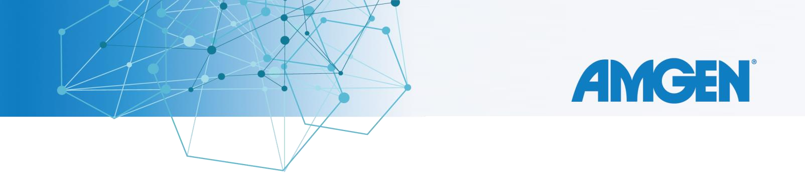

Cordially Invites You to Attend a Program Titled
What You Can Do Today For Your KRAS G12C – Mutated NSCLC

Patients Speaker:
ROBERT WEBER, MD

Fleming's Prime Steakhouse and Wine Bar Calistoga Room 180 El Camino Real Palo Alto, CA 94304 (650) 329-8457

Wednesday, May 18, 2022 6:30 PM Pacific

Please RSVP to: AnneMarie Merrick Phone: (831) 200-6055
E-mail: amerrick@amgen.com

PhRMA guidance: Effective January 1, 2022 the PhRMA Code was revised to include certain new requirements for industry provided Speaker Programs. To comply with these new requirements, Amgen will no longer pay for or provide alcohol in connection with our Speaker Programs.
Amgen’s COVID-19 speaker program risk mitigation guidance: To mitigate the risk of COVID-19 transmission and in accordance with CDC guidance, attendees are asked to wear a face mask, and follow the local social distance and safety guidance at all times. Individuals exhibiting signs and symptoms of COVID-19 infection should not attend.
Notice: This event is conducted in accordance with the PhRMA Code on Interaction with Healthcare Professionals and is limited to invited healthcare professionals. Attendance by guests or spouse is not appropriate. Government employees are subject to state and federal laws and ethics rules that may limit your ability to receive any gifts, including meals, from pharmaceutical companies. If you are a state or federal employee, it is your responsibility to seek guidance and prior approval from your employer or site ethics counselor to attend this event.
State Laws: To comply with law and Amgen policies, Amgen is unable to offer food and beverages to (1) individuals with prescribing authority in Vermont or Minnesota; or (2) individuals employed by prescribers in Vermont who support the provision of healthcare. Please confirm the value of the meal with your Amgen representative before accepting the meal. You have the opportunity to opt-out of the meal and/or purchase your own meal, if applicable.
Please note that Amgen exercises diligence in reviewing the licensure of attendees and asks that you cooperate by disclosing all licensures in the sign-in/registration process. We appreciate your understanding and support.
Disclosure by Amgen: Amgen reports payments and transfers of value made to healthcare professionals and other healthcare related entities in accordance with federal and state laws, regulations and other transparency obligations. Any items of value provided by Amgen at this event (including the provision of meals and refreshments) may be subject to public disclosure. If you have questions regarding this matter please contact Amgen at 805-447-7422 or HCCSpendInquiry@amgen.com.
(c) 2021 Amgen Inc. All rights reserved.
USA-CBU-80322

