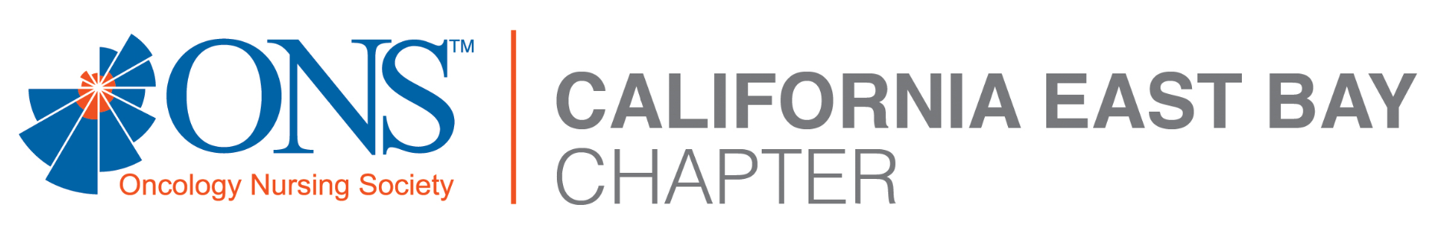

CALIFORNIA EAST BAY ONCOLOGY NURSING SOCIETY (CEBONS)
INVITES YOU TO OUR MONTHLY MEETING
Because of the COVID-19 pandemic restrictions –
This meeting will be VIRTUAL Via Zoom
TUESDAY, May 18th, 2021 Agenda
REGISTRATION 6:00 – 6:30 PM
(Join us early for games/prizes at 6:20 PM)
6:30 PM – CEBONS Meeting and Virtual Displays
7:00 PM – “Meeting the Many Challenges of AML:
Oncology Nurse Tactics in an Era of Novel Therapies”
Sara M. Tinsley, PhD, APRN, AOCN®
Nurse Practitioner, Malignant Hematology
Moffit Cancer Center // Tampa, FL
Sponsored by PeerView Institute for Medical Education (PVI)
8:00 pm – Q & A / Concluding remarks
(**Note – PVI will be offering 1.0 NCPD for this presentation**)
We’ll be creating a “sign-in” sheet for the NCPD
(and, to prevent “Zoom Bombers”)
Please RSVP with your FULL NAME, BRN #, and your employer by:
No later than 5 PM Sunday, May 16th, 2021 via email to:
cebonsrsvp@gmail.com
Please join us on Zoom (Note: link sent with RSVP confirmation)

